**QA Screening Questions: -**

1. Acceptance criteria verification: Please manually verify the following  
   acceptance criteria on the following website: <https://www.rabbitscams.sex/>

Feature:  
● When I enter text in the search box on Rabbits Cams, I expect to see a  
reference to that text in the provided results.

Scenario:  
● Given that I have opened the Rabbits Cams search menu on a mobile  
device  
● When I add "jenny" to the search box  
● And click the Search Button  
● Then performers with "jenny" in their name should be mentioned in the  
results

**Result: -**

When we open the url on the mobile device for the first time, then by default we see as shown below: -

It is highlighted towards **Girls** section by default



**When we search for jenny in the search box and click on search button then we observe the results as mentioned below: -**



**It says jenny sex cams and it displays all the people having name jenny.**

**Now,** when we highlight towards **Guys** section, as shown below and try to search for jenny and click on search button then we observe that we do not get any matching result. Screenshot for it is also attached



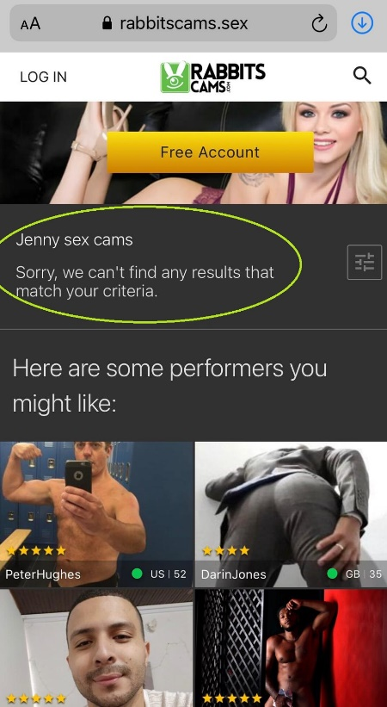

2:- Scenario:  
● Given that I have opened the Rabbits Cams search menu on a mobile  
device  
● When I add "nathanial" to the search box  
● And click the Search Button  
● Then performers with "nathanial" in their name should be mentioned in  
the results

**Results: -**

By default, we observe that it is highlighted towards Girls section,

When we try search for “nathanial” in the search box then we do not see any matching result corresponding to the search criteria. Screenshot is attached below

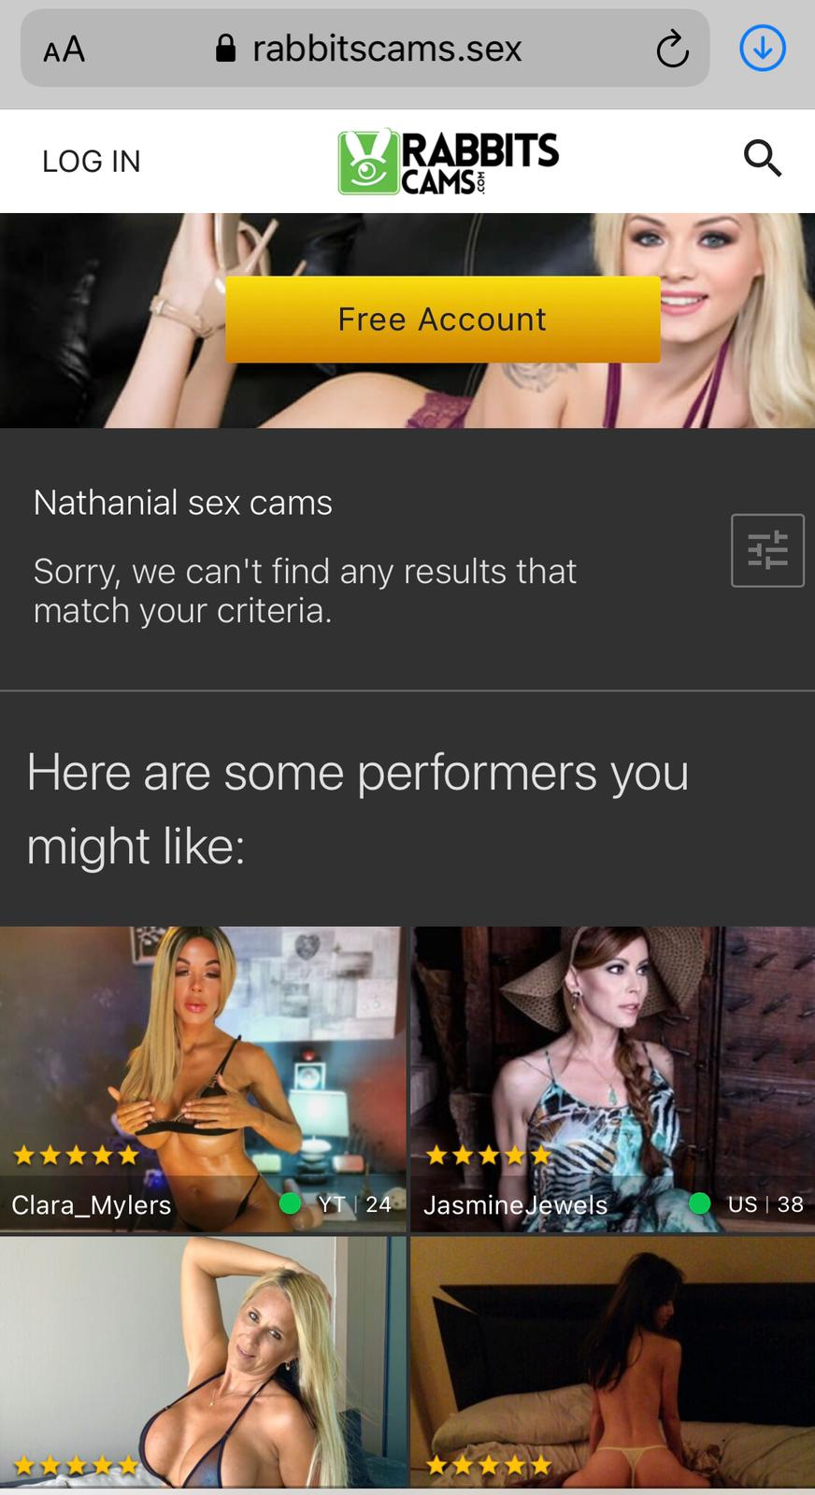

Even when we point towards the guy section and search for nathanial in the search box, then also we do not see any corresponding results.

**2: -** **Written test case: Write a functional test case that could be used for  
automation based on the mobile version of the following page:**[**https://www.rabbitsreviews.com/index.html**](https://www.rabbitsreviews.com/index.html)

**Feature:-** Verifying that a user is able to successfully login to his/her account and log out as well

Steps: -

1:- The user opens to the chrome Browser and enter Url:- [**https://www.rabbitsreviews.com/index.html**](https://www.rabbitsreviews.com/index.html)

2: - Validates the title of the application to make sure it has used the correct url

3: - Click on Enter button in order to Login to his/her account

4: - User then selects the Log in section

5: - The user then enter valid Email and Password and afterwards click on Login button

6: - Then it validates the header title to make sure it has been successfully logged in

7:-Then click on Logout button